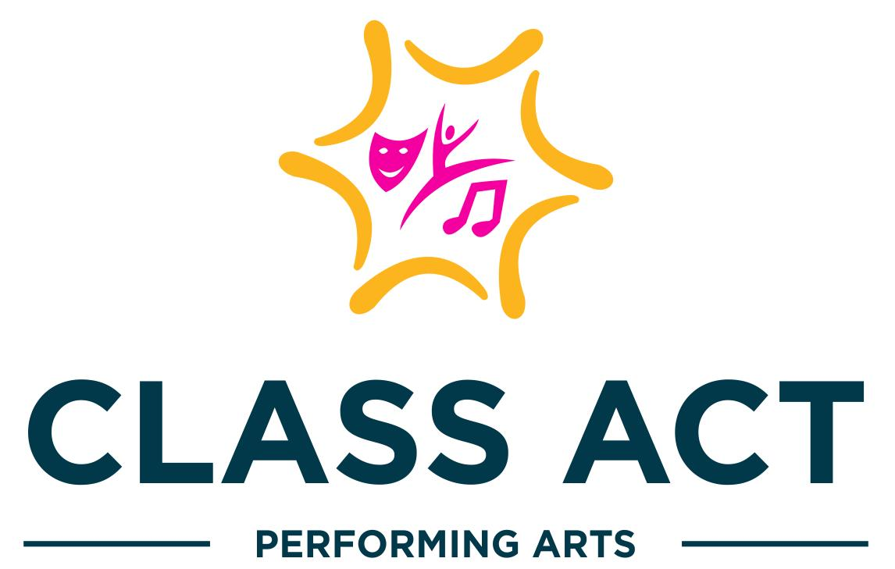
2022-2023
Handbook

Class Descriptions
Clothing comfortable for movement, no specific dress code.
Appropriate shoes are required for all classes.
Participants are HIGHLY encouraged to bring a water bottle to class; water only!
CAPA Toddlers | CAPA Kids  Level 1 | CAPA Kids  Level 2 | CAPA  Tweens | CAPA  Teens | CAPA  Adults
3-4 years old (preschool) | 5-6 years old  (K-1st grade) | 7-9 years old  (2nd-4th grade) | 10-12 years old  (5th-6th grade) | 13+ years old | 18+ years old
Taps & Toes  1 hour class  Ballet Slippers &  Tap shoes required | Ballet & Tap  1 hour class  Ballet Slippers &  Tap shoes required | Ballet & Tap  1 hour class  Ballet Slippers &  Tap shoes required | Ballet & Tap  1 hour class  Ballet Slippers &  Tap shoes required |  | Barre & Ballet  1 hour class  Ballet Slippers required
Hip-Hop & Tumble  1 hour class  Sneakers required | Hip-Hop & Tumble  1 hour class  Sneakers required | Hip-Hop & Tumble  1 hour class  Sneakers required | Hip-Hop  1 hour class  Sneakers required | Hip-Hop  1 hour class  Sneakers required | Hip-Hop  1 hour class  Sneakers required
 | Jazz & Tumble  1 hour class  Jazz shoes required | Jazz & Tumble  1 hour class  Jazz shoes required | Jazz & Tumble  1 hour class  Jazz shoes required
 | Jazz & Theatrics (acting)  1 hour class  Jazz shoes required | Jazz & Theatrics (acting)  1 hour class  Jazz shoes required | Jazz & Theatrics (acting)  1 hour class  Jazz shoes required | Jazz & Theatrics (acting)  1 hour class  Jazz shoes required
 | Lyrical  1 hour class  Jazz shoes required | Lyrical  1 hour class  Jazz shoes required | Lyrical  1 hour class  Jazz shoes required | Lyrical  1 hour class  Jazz shoes required
 | Musical Theater  Jazz & Tap  1 hour class  Jazz & Tap shoes required | Musical Theater  Jazz & Tap  1 hour class  Jazz & Tap shoes required | Musical Theater  Jazz & Tap  1 hour class  Jazz & Tap shoes required | Musical Theater  Jazz & Tap  1 hour class  Jazz & Tap shoes required | Musical Theater  Tap (ONLY)  1 hour class  Tap shoes required

Class Fees & Performance Information
1 hour classes
Fall-Winter Session $240 per session/12 weeks
Spring Session $280 per session/14 weeks
Summer Session $250 per week/full day

Billing Cycles:
Fall -Winter Session ($240/12 weeks) fees due at registration
Spring Session ($280/14 weeks) fees due at registration
Summer Sessions ($250/1 week) fees due at registration
*ALL payments should be made via Parent Portal.
* ALL fees will be suspended, refunded or credited in case of studio closing per CDC, State of Maryland and Anne Arundel County guidelines.

Discounts:
2+ classes/participants 10% off total tuition each session

Make-Up Classes:
If participants are unable to attend their regularly scheduled class due to illness, schedule conflict, etc. they may attend a comparable class (be sure to ask for suggestions) to make up for the class missed.

Performance Information:
Winter Showcase December 18th, 2022 at Bowie Center for the Performing Arts
Spring Showcase Location and Date will be communicated at a later date.
Each performance will have a MANDATORY dress rehearsal. Location and Date will be communicated.

Performance Fees:
$150 per performer includes:
Costume(s) & Tights
Show T-shirt
Floral Bouquet
Professional Video Recording

Safety Procedures

Sick Policy:

If a participant is sick he/she may not attend class. Please inform the class teacher and a makeup class can be arranged. Refunds will NOT be provided for missing classes, however makeup classes will be offered.
COVID - 19 Protocol: Class Act Performing Arts will follow the following protocol to keep our participants, families and staff members safe.
- Participants will be allowed, but not required, to wear face masks during class time.
- Parents/guardians that become aware of their child exhibiting a fever of 100.4 degrees (F) or higher, coughing, or any other symptoms that indicate illness, will be asked to keep their child home.
- If your child tests positive for any illness during, we ask that they refrain from coming to class. Make-up classes will be offered.
- We ask that parents/guardians ensure that their children have used the restroom and washed their hands prior to arriving.
- Participants will be permitted to use the restrooms while in class. Staff will monitor proper hand-washing.
- No sharing water bottles.

Liability Disclaimer:

All participants and parents/guardians are required to sign a medical release form absolving CAPA from liability in the case of an emergency. We also require a medical emergency number to be on file for each student.

Leaving the Studio:

Participants are strictly prohibited from waiting outside, or sitting outside the studio alone. If participants go outside for any reason, they must have permission from a staff member.

Studio Closings
Please follow us on Social Media (Facebook & Instagram). All emergency closings will be emailed and posted on our pages.
Weather Closings:
Class Act Performing Arts will most likely follow Anne Arundel County Public Schools' inclement weather plan. Make-up classes will be rescheduled in case of closing due to weather.
Holiday Closings:
All holiday closings for the studio are posted on the Google Calendar in the “Classes” section of our website; Thanksgiving Break, Winter Break and Spring Break.

