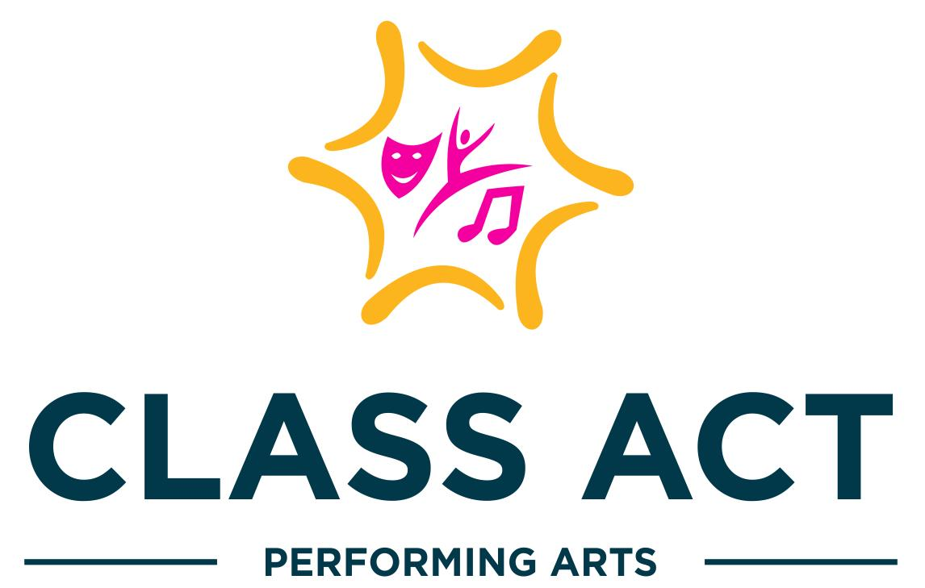
2023-2024
Handbook

Class Descriptions
Clothing comfortable for movement, no specific dress code.
Appropriate shoes are required for all classes.
Participants are HIGHLY encouraged to bring a water bottle to class; water only!
CAPA Toddlers | CAPA Kids  Level 1 | CAPA Kids  Level 2 | CAPA  Tweens | CAPA  Teens | CAPA  Adults
3-4 years old (preschool) | 5-6 years old  (K-1st grade) | 7-9 years old  (2nd-4th grade) | 10-12 years old  (5th-6th grade) | 13+ years old | 18+ years old
Taps & Toes  1 hour class  Ballet Slippers &  Tap shoes required | Ballet & Tap  1 hour class  Ballet Slippers &  Tap shoes required | Ballet & Tap  1 hour class  Ballet Slippers &  Tap shoes required | Ballet  (Non-Performance)  1 hour class  Ballet Slippers required | Ballet  (Non-Performance)  1 hour class  Ballet Slippers required | Barre & Stretching  1 hour class  Ballet Slippers required
Hip-Hop & Lyrical  1 hour class  Jazz or Sole Shield shoes for Lyrical,  Sneakers for Hip Hop required | Hip-Hop & Lyrical  1 hour class  Jazz or Sole Shield shoes for Lyrical,  Sneakers for Hip Hop required | Hip-Hop & Lyrical  1 hour class  Jazz or Sole Shield shoes for Lyrical,  Sneakers for Hip Hop required | Hip-Hop  1 hour class  Sneakers required | Hip-Hop  1 hour class  Sneakers required | Jazz  1 hour class  Jazz shoes required
 | Jazz & Tap  1 hour class  Jazz & Tap shoes required | Jazz & Tap  1 hour class  Jazz & Tap shoes required | Jazz  1 hour class  Jazz shoes required | Jazz  1 hour class  Jazz shoes required | Tap  1 hour class  Tap shoes required
 | Theatrics (acting)  1 hour class  Jazz shoes required | Theatrics (acting)  1 hour class  Jazz shoes required | Lyrical  1 hour class  Jazz or Sole Shield shoes required | Lyrical  1 hour class  Jazz or Sole Shield shoes required
 | Cheer & Tumble  1 hour class  Sneakers required | Cheer & Tumble  1 hour class  Sneakers required | Tap  1 hour class  Tap shoes required | Tap  1 hour class  Tap shoes required

Class Fees & Performance Information
Fall-Winter Session $240 per session/12 weeks
Spring Session $350 per session/16 weeks
Summer Session
Musical Theater Camp $350/week 9am-2pm
Dance Camp $250/week 9am-12pm or 2pm-5pm

Billing Cycles:
Fall -Winter Session ($240/12 weeks) fees due at registration
Spring Session ($350/16 weeks)
½ charged at registration $175
½ automatically charged on January 15th $175
Summer Sessions fees due at registration
*ALL payments should be made via Parent Portal.
* ALL fees will be suspended, refunded or credited in case of studio closing per CDC, State of Maryland and Anne Arundel County guidelines.

Discounts:
MultiStudent or MultiClass Discount: 10% off

Make-Up Classes:
If participants are unable to attend their regularly scheduled class due to illness, schedule conflict, etc. they may attend a comparable class (be sure to ask for suggestions) to make up for the class missed.

Performance Information:
Winter Showcase December 10th, 2023 at Bowie Center for the Performing Arts
Spring Showcase TBD
Each performance will have a MANDATORY dress rehearsal. Location and Date will be communicated.

Performance Fees:
$150 per performer includes:
Costume(s) & Tights
Show T-shirt
Floral Bouquet
Professional Video Recording
Safety Procedures

Sick Policy:

If a participant is sick he/she may not attend class. Please inform the class teacher and a makeup class can be arranged. Refunds will NOT be provided for missing classes, however makeup classes will be offered.
- Participants will be allowed, but not required, to wear face masks during class time.
- Parents/guardians that become aware of their child exhibiting a fever of 100.4 degrees (F) or higher, coughing, or any other symptoms that indicate illness, will be asked to keep their child home.
- If your child tests positive for any illness during, we ask that they refrain from coming to class. Make-up classes will be offered.
- No sharing water bottles.

Liability Disclaimer:

All participants and parents/guardians are required to sign a medical release form absolving CAPA from liability in the case of an emergency. We also require a medical emergency number to be on file for each student.

Leaving the Studio:

Participants are strictly prohibited from waiting outside, or sitting outside the studio alone. If participants go outside for any reason, they must have permission from a staff member.

Studio Closings
Weather Closings:
Class Act Performing Arts will most likely follow Anne Arundel County Public Schools' inclement weather plan. Make-up classes will be rescheduled in case of closing due to weather. Please follow us on Social Media (Facebook & Instagram). All emergency closings will be emailed and posted on our pages.
Holiday Closings:
All holiday closings for the studio are posted on the Google Calendar in the “Classes” section of our website; Halloween evening, Thanksgiving Break, Winter Break and Spring Break.

